**Hazel Sive (short CV)**

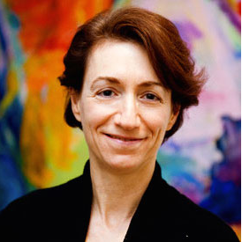

Hazel Sive is an expert in developmental biology, member of the Whitehead Institute, Professor of Biology and Associate Member of the Broad Institute at MIT. Prof. Sive received the B.Sc. Hons. from the University of Witwatersrand in Johannesburg, South Africa, the Ph.D. in 1986 from Rockefeller University, New York; and carried out postdoctoral research at the Fred Hutchinson Cancer Center, Seattle (WA), before joining the MIT faculty in 1991. Sive was the first Associate Dean for the MIT School of Science and is Founding Coordinator of the MIT-AFRICA Initiative. Most recently, she was named a 2015 MacVicar Faculty Fellow, MIT’s highest teaching award. She is Director of the new MIT-Educator Program that focuses on university curriculum design, incorporating problem-solving, digital and entrepreneurial approaches.